**Vishal Naik**

**Msc Ai**

**12**

**3.1 Branches in a Nutshell**

### **Creating a New Branch**

What happens when you create a new branch? Well, doing so creates a new pointer for you to move around. Let’s say you want to create a new branch called testing. You do this with the git branch command:



### **Switching Branches**

To switch to an existing branch, you run the git checkout command. Let’s switch to the new vishaltxt branch:

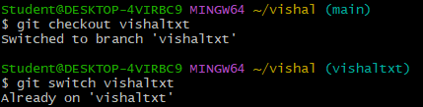

**3.2 Git Branching - Basic Branching and Merging**

### **Basic Branching**

Basic branching in Git allows you to create separate lines of development without affecting the main branch (usually **master** or **main**). Here's how you can create and work with branches in Git:



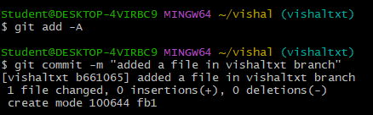

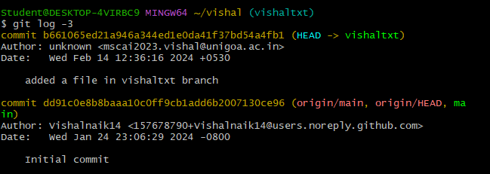

Checking out the git files in main and master

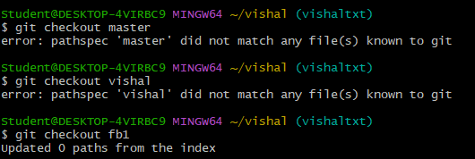

### **Basic Merging**

